05.06.2018

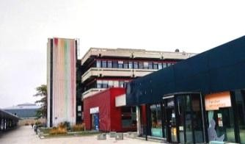
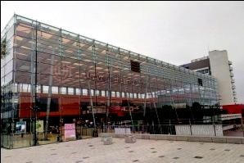
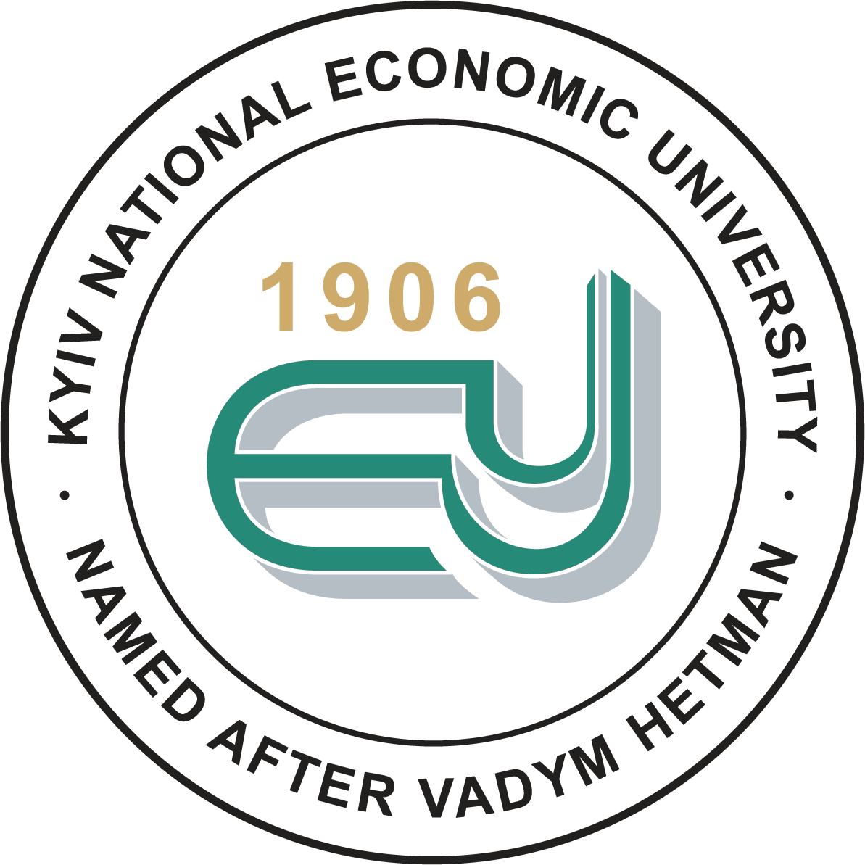
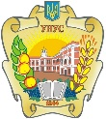
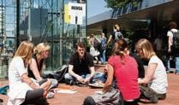
PROJECT CONSORTIA

СAMPUS LIFE LEARN CULTURE AND
LANGUAGE
LECTURES
COLLECT ECTS
RESOURCES CONNECT TO ACADEMIC WORLD

COME TO BREMEN!

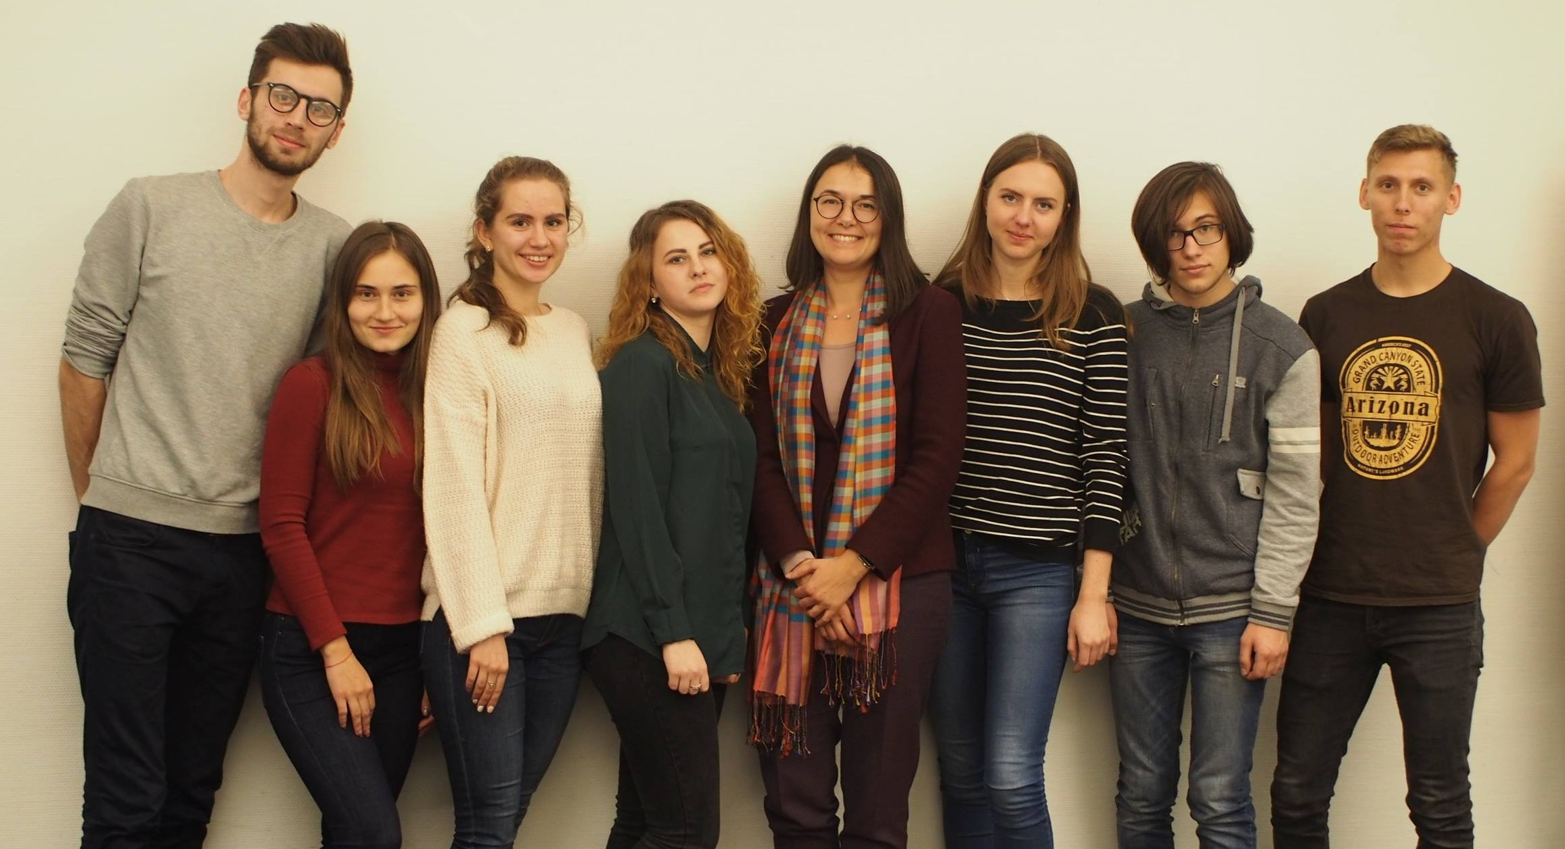

Our offer
The Ukrainian partner universities are preparing a German-Ukrainian master program in logistics (GUMLog for short) with the University of Bremen, Germany. One part of this four-year collaboration is student mobility. In 2018 there are eight grants available worth 750 euro each apart from a pre-booked air ticket. Exchange time - one month (1/October/2018 - 1/November/2018) studying during winter semester 2018.
Nominated students will be expected to:
- collect ECTS participation of the seminar "Global logistics" in the University of Bremen (October-November/2018).
- visit 1 additional course (without collecting ECTS). Please, choose available courses taught in English, please click here.

The nomination will be decided following a Skype interview.
After nomination you will have to find accommodation and to apply for a visa if nessasury.

DEADLINES

APPLICATION
6/September/2018

NOMINATION
26/September/2018

BEGIN OF STUDY
1/October/2018

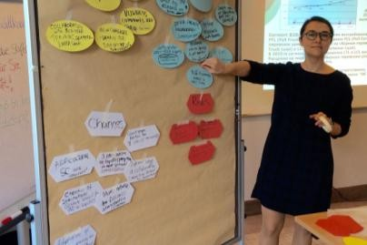
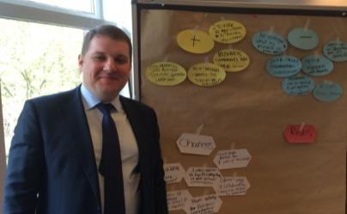
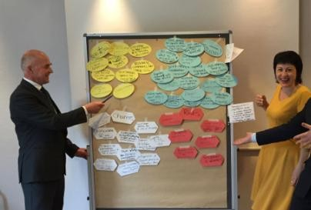
05.06.2018

Creative bachelor, master or PhD students are welcome to apply for funding!

Nomination will be made by GUMLog project consortia, represented by:

Dr. Irina Dovbischuk (University of Bremen)

Prof. Oleksandr Dyma (Kyiv National Economic University)

Dr. Natalia Verniuk
(Uman National University of Horticulture)

In order to create your timetable and choose available courses taught in English, please click here.

Copyright of all pictures: University of Bremen

Requirements
- You are an enrolled bachelor, master or PhD student at Uman National University of Horticulture;
- You are student of the logistics program;
- You are eager to learn
- Your citizenship is Ukrainian
- You are ready to cover all necessary expenses for preparation of your study time or any additional expenses during your study in Bremen (e.g. medical insurance, travelling, etc)

Selection criteria
- Reliable knowledge of English (30%)
- Motivation letter, including the reasoning for the second subject selected (30%)
- Transcript of academic records (20%)
- Correctness and completeness of application (10%)

Application
Please send your application to Dr. Dovbischuk via email as one PDF document (max. 15 MB), including documents, ordered as it is listed in the following:
- CV in English (without photo);
- Motivation letter in English;
- Overview of at least two courses like a weekly time table;
- Copy of the transcript of academic records (copy of the original in Ukrainian and your translation into English in form of a table, indicating the grade for each subject);
- Copy of enrollment certificate in Ukrainian;
- Copy of passport (issued for foreign travels, if any) Please name the PDF file:
"Candidate’s Surname_GUMLog_MobilityCall_2018".

Contact
Dr. Irina Dovbischuk
Chair in Maritime Business and Logistics Faculty 7: Business Studies and Economics University of Bremen
Wilhelm-Herbst-Str. 12, 28357 Bremen, Germany
+49 421 218 66766
dovbischuk@uni-bremen.de www.mlog.uni-bremen.de

